ABSTRACT

There are many incidents involving crowds such as crowd crushing and stampedes. These incidents include the Hillsborough Disaster, the stampede at Kanjuruhan Stadium and an incident knows as a "crush and stampede" that either suffocated or crushed over 2000 pilgrimages during the annual Hajj pilgrimage. These incidents mainly occur due to poor crowd management, which is done manually most of the time, increasing room for human error. Among the human errors are more people in a specified area compared to the allowed people in that area. Hence, this research studies upon the approach of deep learning to detect and track people in a crowd to observe the number of people in a crowd at a given time. To automate the detection and tracking of people in a crowd, artificial intelligence was implemented. The current research reflects upon the detection and tracking of people in a dense crowd through a topological method implementing graph neural network (GNN). To further understand how these methods are implemented for dense crowd tracking and detection, a systematic literature review (SLR) is carried out. This paper presents an SLR to further analyse similar works of this research as well as what can be improved upon for the current research to fill in the gaps of the previous research. The review covers articles published from February 2019 to February 2024. The Preferred Reporting Items for Systematic Reviews and Meta-Analyses (PRISMA) guidelines were used to carry out the systematic review where the guidelines are implemented for the data collection and analysis of 2080 articles studied across six different databases. From 2080, 30 are the primary studies that met the inclusion criteria. The primary studies will be used as the staple to be analysed and categorised to answer related questions relating to the accuracy of the tracking and detection of people in a dense crowd. This SLR can be used to provide references for research in artificial intelligence and those seeking to implement it and re-identification in the tracking and detection of people in a dense crowd.

KEYWORDS *topology, dense, crowd, track, detect, architecture, re-identification, graph neural network*

Introduction

Crowd detection by Multiple Head Tracking (MHT) is currently one of the most essential and challenging research topics in the computer vision community. Due to the common availability of high-quality low-cost video cameras and considering the inefficiency of manual surveillance and monitoring systems, automated video surveillance is now essential for today’s crowded and complex environments. Accurate information about numbers plays a vital role in operational and security efficiencies for monitoring, controlling, and protecting crowds. The counting and tracking of many persons pose as a challenge due to several reasons that are occlusions, the constant displacement of people, different perspectives and behaviours, varying illumination levels, and because, the bigger the crowd, the lower the allocation of pixels per person.

However, the counting and tracking of people in crowds is important to be implemented. This is due to public domains such as stadiums, airports, and, and even religious gathering areas tend to be difficult to track the number of people in crowds due to its density. This difficulty has proven to be deadly such as the Hillsborough disaster on 15th April 1989, the human “crush and stampede” event that occurred for the Hajj pilgrims on 24th September 2015, and the human crush at Kanjuruhan Stadium on 1st October 2022. Due to these incidents, a question that usually pops up is how can this be avoided or lesson. One of the solutions that was being researched upon was crowd detection using MHT.

Crowd detection by MHT is currently one of the most essential and challenging research topics. However, methods developed by different researchers only produce satisfactory results in sparse crowd setting for crowd detection and tracking. Hence, this area of research needs further elaboration to implement this area of research in dense crowd benchmarks.

It is important to analyse the methods that can be used for tracking and detecting people in a crowd. It is also important to take a step back and understand the flow of how the tracking and detection was originally to how much it has evolved so that the current research can understand more on how the gaps were filled with each new evolution. Similar works to this research need to be researched to understand the methods used by different research to detect and track people in crowds and their gaps for the current research to fill them to be novel research.

There have been many review studies focusing on graph neural network and topology to track or detect people in a crowd. However, some of those studies only either track or detect, not both. Another limitation is that some studies can’t be implemented in public places as the research accommodates simulation or post processing videos. Current architectures implemented in several papers such as yolo was developed to detect object in normal situation and not in a dense environment. There are also problems like difficulty distinguishing an object's uniqueness in a dense environment to reidentify it once it goes offscreen and returns to the camera. Hence, it is important to further filter the papers to review research that are more similar to the current research.

In this paper, our aim is to help other researchers by making a SLR of related studies using topological method and GNN for detection and tracking of people in a crowd. The SLR encompass studies in the last five years that are from February 2019 to February 2024. The main contributions of this systematic review can be summarised as follows:

1. Searching articles from various databases with specific keywords related to current research. Mainly, these researches must include topological method and graph neural network. There are 2083 papers collected using the specified keywords from six databases that are ACM Digital Library, Wiley Online Library, SpringerLink, ScienceDirect, IEEExplore, and SciSpace. The research taken must have a published date within the past five years timeframe.

2. A large-scale literature review is completed using the PRISMA process methodology. The current research proposes three research questions. Firstly, the research questions were formulated. Then, the related studies were collected, the inclusion and exclusion criterias were defined, and from there, the primary studies focused on the related topics were identified with an acceptable quality score.

3. A thorough analysis have been implemented in the primary studies. Each reviewed paper is based on the research questions, involving the current methods of detection and tracking of people in a dense crowd using deep learning approach and whether it is applicable in public places. The aim of this is to provide researchers who on the methods to track and detect people in dense crowds and how their output will be to assist them more in their research.

The remainder of this paper is structured as follows:

1. Section 2: The research methodology involving research questions and research protocols

2. Section 3: The results of the literature review to provide answers and discussions to the initial research questions.

3. Section 4: The limitations of the study

4. Section 5: The conclusion of the research

2. Methodology

The methodology used for the current SLR follows the original guidelines proposed by S. Keele in 2007 in the paper “Guidelines for Performing Systematic Literature Reviews in Software Engineering”. The figure below shows the methodology’s flowchart.

FIGURE 1. SLR’s Methodology

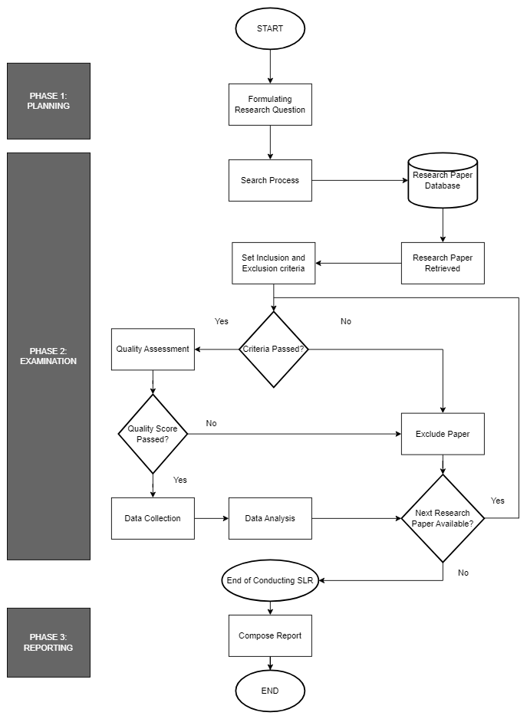

Based on the flowchart, there are 6 main phases for the methodology

A. Planning

The planning phase is where the actions required to achieve the research objectives are decided. In this study, the objectives are related to the topic of the methods and algorithms used in the tracking and detection of people in a dense crowd and if it can be implemented in public places. The keywords to be used to search for papers in the six databases were also planned during this stage. Hence, this step is the foundation of the SLR’s methodology.

B. Formulation of Research Questions

The research questions were discussed and laid out during this phase. The main questions proposed were related to the research project's usability. For example, there has been research about object tracking but they were implemented on post processing videos and not in real time, hence it cannot be used in public places. The method and architecture used for the detection and tracking of people in a dense crowd also serves as questions needed to be answered as different research provides different methods and algorithms that might not be as accurate as other studies and not suitable for dense crowds. Some research focuses on detection only and not tracking. Due to the reasons stated, the research questions formulated are:

RQ1: How to improve upon the current method used to detect people in a dense crowd setting

RQ2: What architecture will be used for tracking people

RQ3: Can it be implemented in public places

C. Search Process

In this subsection, each article to be used for comparing the similar works are identified. The purpose of this phase is to extract relevant experimental studies on the tracking and detection of people in a dense crowd and if they can be implemented in public places. The databases used to get these articles are ACM Digital Library, WIley Online Library, SpringerLink, IEEExplore, ScienceDirect, and SciSpace. The original keywords planned during the planning phase is used to search for related articles in these databases but with a few adjustments. This is due to how some of the repositories have limitations such as how ScienceDirect can only accept a maximum of eight boolean expressions. The keywords are related to the current research such as GNN and topology. Table 1 shows the keywords used for the search query and articles gotten from each repository.

TABLE 1. Search query used for each database and number of papers gotten from them.

|  |  |  |
| --- | --- | --- |
| Database | Search Query | Number of Papers |
| IEEExplore | *("TOPOLOGY") AND ("DENSE CROWD") AND ("TRACK") AND ("DETECT") AND ("ARCHITECTURE") AND ("TRACKING REIDENTIFICATION" OR "RE-IDENTIFICATION" OR "TRACKING RE-IDENTIFICATION" OR "REIDENTIFICATION") AND ("GRAPH NEURAL NETWORK" OR "GNN")* | 1 |
| ACM Digital Library | *("TOPOLOGY") AND ("DENSE CROWD") AND ("TRACK") AND ("DETECT") AND ("ARCHITECTURE") AND ("TRACKING REIDENTIFICATION" OR "RE-IDENTIFICATION" OR "TRACKING RE-IDENTIFICATION" OR "REIDENTIFICATION") AND ("GRAPH NEURAL NETWORK" OR "GNN")* | 1052 |
| ScienceDirect | *("TOPOLOGY") AND ("DENSE CROWD") AND ("TRACK") AND ("DETECT") AND ("ARCHITECTURE") AND ("RE-IDENTIFICATION" OR "TRACKING RE-IDENTIFICATION" ) AND ("GRAPH NEURAL NETWORK" OR "GNN")* | 0 |
| SpringerLink | *("TOPOLOGY") AND ("DENSE CROWD") AND ("TRACK") AND ("DETECT") AND ("ARCHITECTURE") AND ("TRACKING REIDENTIFICATION" OR "RE-IDENTIFICATION" OR "TRACKING RE-IDENTIFICATION" OR "REIDENTIFICATION") AND ("GRAPH NEURAL NETWORK" OR "GNN")* | 1020 |
| Wiley Online Library | *("TOPOLOGY") AND ("DENSE CROWD") AND ("TRACK") AND ("DETECT") AND ("ARCHITECTURE") AND ("TRACKING REIDENTIFICATION" OR "RE-IDENTIFICATION" OR "TRACKING RE-IDENTIFICATION" OR "REIDENTIFICATION") AND ("GRAPH NEURAL NETWORK" OR "GNN")* | 0 |
| SciSpace | *("TOPOLOGY") AND ("DENSE CROWD") AND ("TRACK") AND ("DETECT") AND ("ARCHITECTURE") AND ("TRACKING REIDENTIFICATION" OR "RE-IDENTIFICATION" OR "TRACKING RE-IDENTIFICATION" OR "REIDENTIFICATION") AND ("GRAPH NEURAL NETWORK" OR "GNN")* | 10 |

D. Inclusion and Exclusion Criteria.

The studies included in the SLR were based on specific criterias. This is to filter out the articles to papers that complements the current research. If the papers don’t meet the criterias, they will be excluded and filtered out of the study. Among the most important criterias are that it must be withing the appropriate timeframe that is from the past five years of the current studies to make sure that they are still relevant to the current day and age. Another important factor is that the paper must be written in English. Papers that did not meet these criterias are filtered out. The filtering occurs step by step to have a higher accuracy in filtering the papers. Table 2 refers to the inclusion and exclusion criteria as well as the number of papers excluded.

TABLE 2. Inclusion and Exclusion criteria and papers excluded

|  |  |  |
| --- | --- | --- |
| Inclusion Criteria | Exclusion Criteria | Number of Papers Excluded |
| Articles must be unique | There are duplicated articles | 2 |
| Articles must be open acceessed | Articles can only be viewed by paid subscription or when login with institution credentials | 15 |
| Articles’ titles must relate to the current research | Articles not related to the current research. Main focus is on crowd. If crowd is not present, the article is excluded | 2050 |
| Have an abstract related to the current research | No abstract or abstract not related to current research | 0 |
| Have a DOI or URL | Doesn’t have both URL and DOI | 0 |
| Paper must be in English | Paper is in a language other than English | 0 |
| Paper must be published within 5 years of when the SLR is written (February 2019 to February 2024). | Paper is not published within February 2019 to February 2024 | 0 |

E. Quality Assessment

The studies filtered from the previous step were further filtered through the quality assessment criteria. The main reason for this is although the papers gathered are somewhat related to the current topic, they are not able to help answer the research questions proposed during the research questions’ formulation phase. The quality assessment phase is executed to filter out the best of the best papers that can help answer the research questions proposed in this SLR and extract data from the remaining research studies. The quality criteria is as follows in Table 3.

TABLE 3. Quality Assessment Scoring Criteria

|  |  |
| --- | --- |
| Research Question (RQ) | Score |
| 1 | 1 |
| 2 | 1 |
| 3 | 1 |

The remaining research papers were evaluated against the quality assessment questions shown in Table 3. If RQ1, RQ2, and RQ3 are present, meaning that their score is 3, then the paper is accepted in this SLR. Table 4 shows the current papers, the RQs, and their score.

TABLE 4. Papers, the RQ they answer and their score

|  |  |  |
| --- | --- | --- |
| Paper TItle | RQ answered | Score |
| An End-to-End Transformer Model for Crowd Localization | RQ1, RQ2, RQ3 | 3 |
| Calibration-Free Multi-view Crowd Counting | RQ1, RQ3 | 2 |
| Completely Self-supervised Crowd Counting via Distribution Matching | RQ1, RQ3 | 2 |
| CounTr: An End-to-End Transformer Approach for Crowd Counting and Density Estimation | RQ1, RQ3 | 2 |
| Crowdsampling the Plenoptic Function | RQ3 | 1 |
| Dense Crowds Detection and Surveillance with Drones using Density Maps | RQ1, RQ2, RQ3 | 3 |
| DLMP-Net: A Dynamic Yet Lightweight Multi-pyramid Network for Crowd Density Estimation | RQ1, RQ3 | 2 |
| Handling Heavy Occlusion in Dense Crowd Tracking by Focusing on the Heads | RQ1, RQ2, RQ3 | 3 |
| Locate, Size, and Count: Accurately Resolving People in Dense Crowds via Detection | RQ1, RQ3 | 2 |
| Recent Trends and Study on Perspective Crowd Counting in Smart Environments | RQ1, RQ3 | 2 |
| Robust Identification of Dense or Sparse Crowd Based on Classifier Fusion | RQ1, RQ3 | 2 |
| Scale-Aware Multi-stage Fusion Network for Crowd Counting | RQ1, RQ3 | 2 |
| Spatio-Channel Attention Blocks for Cross-modal Crowd Counting | RQ1, RQ3 | 2 |
| The Impact of Animations in the Perception of a Simulated Crowd | - | 0 |
| Tracking Pedestrian Heads in Dense Crowd | RQ1, RQ2, RQ3 | 3 |

F. Data Collection

After the quality assessment phase, data extraction is implemented on the remaining papers which are now used as the primary studies. The reason is to find the strong point of each research paper that can answer a specific research question. Table 5 shows the research paper along with their most respected research question and how it helped to answer it.

TABLE 5. Primary Studies and its most respected RQ

|  |  |
| --- | --- |
| Primary Study | Respected RQ |
| An End-to-End Transformer Model for Crowd  Localization | RQ1 |
| Dense Crowds Detection and Surveillance with Drones using Density Maps | RQ3 |
| Handling Heavy Occlusion in Dense Crowd Tracking by Focusing on the Heads | RQ2 |
| Tracking Pedestrian Heads in Dense Crowd | RQ2 |

Figure 2 shows the PRISMA process implemented during the SLR from the papers gotten until the papers used as primary studies.

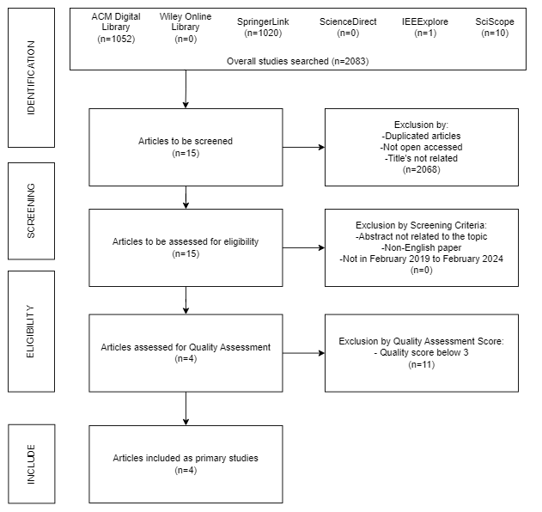

FIGURE 2. PRISMA Diagram for the current SLR

G. Data Analysis

This is the final step of the SLR methodology where the primary studies and the data extracted from them ara analysed to answer the research questions according to the strong points of each paper.

3. Result and Analysis

In this SLR, there are 4 primary studies obtained after the PRISMA process from 2083 studies collected from six different databases. These primary studies will be used to answer the research questions proposed at the start of the SLR. A summary of the primary studies can be found in Table 6.

TABLE 6. Summary of Primary Studies

|  |  |  |  |  |  |  |
| --- | --- | --- | --- | --- | --- | --- |
| ID | TITLE | REFERENCE | PUBLISHER | TYPE | RESPECTED RQ | YEAR |
| PS1 | An End-to-End Transformer Model for Crowd Localization | (Liang et al., 2022) | SpringerLink | Conference Paper | RQ1 | 2022 |
| PS2 | Dense Crowds Detection and Surveillance with Drones using Density Maps | (Javier Gonzalez et al., 2020) | SciSpace | Journal Article | RQ3 | 2020 |
| PS3 | Handling Heavy Occlusion in Dense Crowd Tracking by Focusing on the Heads | (Zhang et al., 2024) | SpringerLink | Conference Paper | RQ2 | 2024 |
| PS4 | Tracking Pedestrian Heads in Dense Crowd | (Ramana Sundaramanet al., 2021) | SciSpace | Journal Article | RQ2 | 2021 |

VOSviewer was used to conduct a brief data analysis on the keywords found in the primary studies’ title and abstract to determine the relationships and key aspects between them. Figure 3 shows the output of VOSviewer.

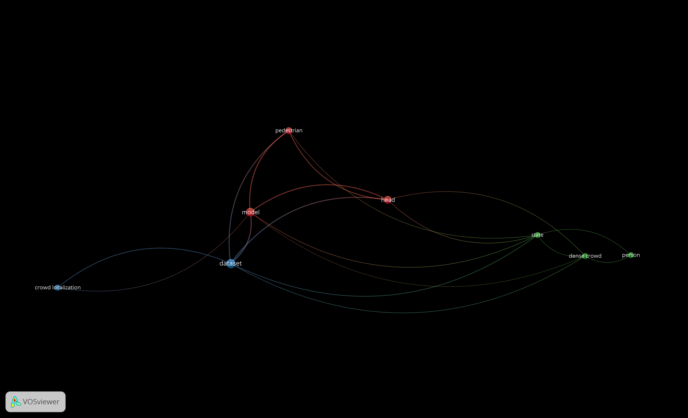

FIGURE 3. Key items of the primary studies visualised by VOSviewer

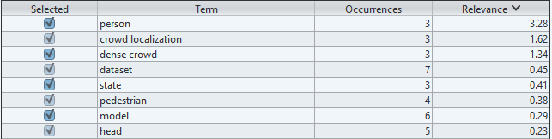

FIGURE 4. Terms of key items from primary studies that are visualised by VOSViewer

Based on Figure 3 and Figure 4, technical terms such as dataset and model have the highest and second highest occurrences across all four primary studies. However, the third highest occurence is the term head, which refers to tracking and detection by detecting the head of the individual. This has been an important technique being researched in the current research for using the head of individuals of people in a dense crowd as nodes for GNN to be detected and tracked. The terms crowd localization and dense crowd also has repeated occurences over the four primary studies, which can be used to not only answer the research question but support the current research. We can conclude that the methodology implemented in the primary studies along with their background are valid and are topic focused. This can also lead to the argument that the review based on the primary studies are valid.

RQ1: How to improve upon the current method used to detect people in a dense crowd setting

Despite all studies being able to detect people in a dense crowd setting, the study and experiment of PS1 shows an almost similar topic to the current research. PS1 uses the localization method to detect people in a dense crowd. Based on the experiments shown in the study, datasets with dense crowds were used for testing PS1’s method of detecting people. Localization method also has an advantage in detection as it helps to annotate the heads of people in crowds to be used for detection. This will not cause occlusion as head detection requires a smaller box compared to that of full body detection. PS1 also uses a transformer model for the localization method which increased its accuracy in detection, which even outperforms the topology method of localization that the current study is researching on. However, there is a significant limitation that needs to be filled in by the current research that is exclusion of large heads during detection. This is due to the experiment’s architecture whereby it crops a fixed size sub-image for training and testing. This will cause failure in detecting extremely large heads. Another limitation is that there might be fake detections. This refers to fake people like people in a poster or tv show being detected and counted as a person in a crowd. These limitations have a workaround the get fixed. Hence, the method proposed in PS1 has shown that it improves upon the current method to detect people in a dense crowd setting as it has a high accuracy when using datasets of very dense crowds such as the Hajj pilgrimage.

Due to the reasons stated, PS1 proves to answer RQ1 efficiently and can serve as an inspiration for the method of detection of people in a dense crowd.

RQ2: What architecture will be used for tracking people

The primary studies that were filtered accommodate RQ2 as they involve the tracking of humans in a dense crowd. However, PS3 and PS4 are heavily focused on tracking compared to the other two primary studies.

PS4 is heavily focused on tracking, although it can also be used for detection. In this study, a new dataset is introduced for tracking by head detection. To further improve the efficiency of tracking pedestrian motion, a new metric is also introduced. Two new baselines were developed for head tracking. This already solves one problem with detection and tracking that is occlusions when tracking because the detection box covers the whole body and might cover another person. Two of the methods executed during the experiment that are particle initialization, and prediction and update, also helps to answer one of the common questions in tracking humans in a crowd that is how to reidentify the same people in the video to track their movements. This also allows the same person to be reidentified when they leave and rejoin the scene. The drawback is that it was not tested in real-time but it has shown that it can be implemented in public places. It also uses its own dataset. However, it serves as a foundation for future research on tracking methods as the algorithms and methods developed in this paper has a high performance with a modest computational complexity.

PS3 is also heavily focused on tracking people in a dense crowd. This primary study is the latest to be published. This paper proves that head detection is the method to handle heavy occlusions in dense crowd tracking. By reducing the occlusions, the accuracy for traking increased. One inspiration from this study’s experiment is that although the person’s head is hidden by an object, the Joint SimOTA module implemented manage to help predict the head of the person thanks to the body part of the pedestrian being present. It also got better results in detection compared to the method in PS3. It has the same drawback with PS4 where it is tested with datasets and not real-time but it has shown that it can be implemented in public places especially in dense crowds.

PS3 is used to answer RQ2 and helps the current research to track and predict the head of people covered in the scene during the tracking of the experiment. PS4 is used to answer RQ2 as well for reidentification of people in dense crowd tracking to avoid duplicated tracking of the same person that will produce inaccuracies in the results.

RQ3: Can it be implemented in public places

PS2 is studied further to answer this research question. Although all the studies can be implemented in public places with a camera, PS2’s experiment and study managed to innovate the manner of implementing the tracking and detection of people in public places. The study uses a drone to estimate the number of people in a crowd. The major advantage this study has is that it has been proven to be applicable in public places such as in the garden and fountain. The results of the tracking and detection has been uploaded to youtube by the authors of the study. The main limitation of the experiment in this study is that the detection of people is not by head detection but by full body detection. This will cause occlusions during the detection as a person’s body part might overlap with another person. This will reduce the accuracy of detection and tracking of people in a dense crowd. Compared to head detections like PS3 and PS4, the full body detection of PS2 will produce lower accuracy.

Due to the reasons stated, PS2 is most suitable to answer RQ3 but is weak to answer RQ1 and RQ2. It can also serve as an inspiration for the current study’s experiment.

4. Limitation

The SLR about the tracking and detection of people through a deep learning approach is conducted based on four primary studies between February 2019 to February 2024. However, there is a possibility that the result of the SLR is affected by a few factors. These factors are the coverage of the search strategy and quality assessment inaccuracy. These factors have been discussed and explained further in this section.

The coverage of the search strategy influences the number of papers gotten across different online databases. The keywords used need were related to the current research such as GNN, topology and dense crowd. The boolean expression used can also influence the number of papers retrieved from the databases. While using the AND boolean expression, that keyword must be available in the topic. While using the OR boolean expression, as long as either keywords in the OR statement is available, the paper with that keyword is picked. ScienceDirect also has a limit of 8 boolean expressions. Hence, the search criteria for ScienceDirect is altered compared to the other databases’ searches. The search criteria as well might retrieved more or less articles by adding, changing, or removing keywords. ACM and SpringerLink also gave books instead of papers. Zotero is then used to extract the articles from each book, making most of the papers retrieved not complementing the current research. Thus, these reasons might affect the searching phase of the SLR.

The quality assessment might also affect the SLR. This is due to how the final exclusion of the papers before the current study gets the primary studies relies on the quality fo the papers. If the papers do not meet the quality score set during the section, the paper will be excluded. There are only 3 research questions that the quality score is based on, and there are no subsections. The strictness of the quality set and the number of research questions will influence the final number of primary studies.

5. Conclusion

Detection and tracking of people in a dense crowd is an essential research as there have been many accidents that have happened due to bad crowd management. To further the current study that is to track and detect people in a dense crowd through a deep learning approach, a SLR must be carried out to understand the methods and architectures used for tracking and detection of people in a crowd by similar studies. Research questions were formulated for the current study to be solved by the primary studies of the SLR. 2083 articles were originally obtained when six online repositories were searched using specific keywords. The number of articles was filtered down to 4 primary studies published from February 2019 to February 2024. The filtering includes exclusion of papers that are not related to the topic, not English, and doesn’t achieve the target of the quality score set. The primary studies are then used to answer the three research questions where each primary study is researched more to see which research question it is most suitable to fill in the gap. The datasets used by the primary studies were also researched in further detail. Finally, the limitations of the studies were researched and the future directions for researchers who are keen on this area of research were discussed. The aim of this paper is to serve as a guide for researches in this area of study through the help of a systematic review of the methods and architectures of detection and tracking of people in a dense crowd where the experiment of the research can be carried out in public places.

6. Reference

Jing Li (2023) ‘A systematic literature review on feature selection for machine learning-based attack classification for IoT security’, *Int. J. Sensor Networks*, Vol. X, No. Y4, pp.000---000.

Liang, D., Xu, W., & Bai, X. (2022). An End-to-End Transformer Model for Crowd Localization. In S. Avidan, G. Brostow, M. Cissé, G. M. Farinella, & T. Hassner (Eds.), *Computer Vision – ECCV 2022* (pp. 38–54). Springer Nature Switzerland. <https://doi.org/10.1007/978-3-031-19769-7_3>

Zhang, Y., Chen, H., Lai, Z., Zhang, Z., & Yuan, D. (2024). Handling Heavy Occlusion in Dense Crowd Tracking by Focusing on the Heads. In T. Liu, G. Webb, L. Yue, & D. Wang (Eds.), *AI 2023: Advances in Artificial Intelligence* (pp. 79–90). Springer Nature. <https://doi.org/10.1007/978-981-99-8388-9_7>

Javier Gonzalez-Trejo & Diego Alberto Mercado-Ravell. (2020). Dense Crowds Detection and Surveillance with Drones using Density Maps. *arXiv: Computer Vision and Pattern Recognition*. <https://doi.org/10.1109/ICUAS48674.2020.9213886>

Ramana Sundararaman, Cedric De Almeida Braga, Eric Marchand, & Julien Pettré. (2021). *Tracking Pedestrian Heads in Dense Crowd*. 3865–3875. <https://doi.org/10.1109/CVPR46437.2021.00386>

Preferred Reporting Items for Systematic Reviews and Meta-Analyses. (n.d.). Wikipedia. Retrieved February 12, 2024, from <https://en.wikipedia.org/wiki/Preferred_Reporting_Items_for_Systematic_Reviews_and_Meta-Analyses>

Deep-Learning based Object Detection in Crowded Scenes. (n.d.). Medium. Retrieved February 12, 2024, from <https://towardsdatascience.com/deep-learning-based-object-detection-in-crowded-scenes-1c9fddbd7bc4>